# **Name: Abdurrahman Qureshi**

# **Roll No: 242466**

Practical No: 3

Date Of Performance: 31/07/2025

Aim:

THEORY:

Q) Implement hello world example in java script. Run on browser and console using node

CODE (Browser):

<!DOCTYPE html>

<html>

    <head>

        <title>Hello World</title>

    </head>

    <body>

        <h1>Hello, World!</h1>

        <script>

            console.log("Hello, World! (from Firefox)");

            alert("Hello, World!");

        </script>

    </body>

</html>

OUTPUT:

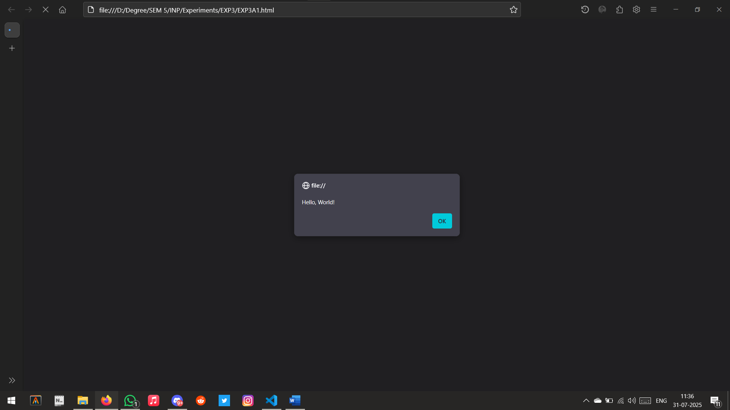

CODE (Console):

console.log("Hello, World! (from Node)");

OUTPUT:



Q) Implement DOM manipulation for change in color of text to red

CODE:

<!DOCTYPE html>

<html>

    <head>

        <title>Change to Red</title>

    </head>

    <body>

        <h1 id="text">Change my color!</h1>

        <button onclick="changeColor()">Click to change color</button>

        <script>

            const changeColor = () => {

                const heading = document.getElementById("text");

                heading.style.color = "red";

            };

        </script>

    </body>

</html>

OUTPUT:

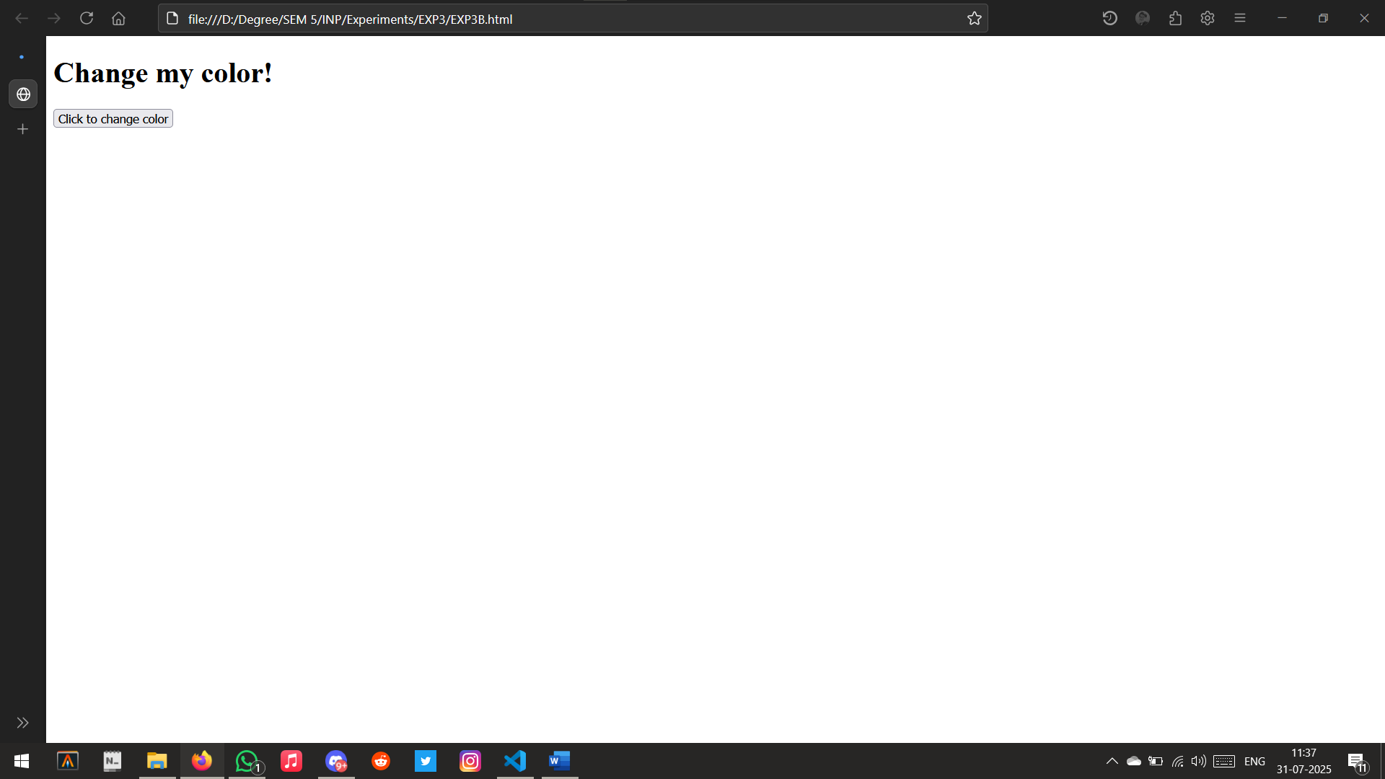

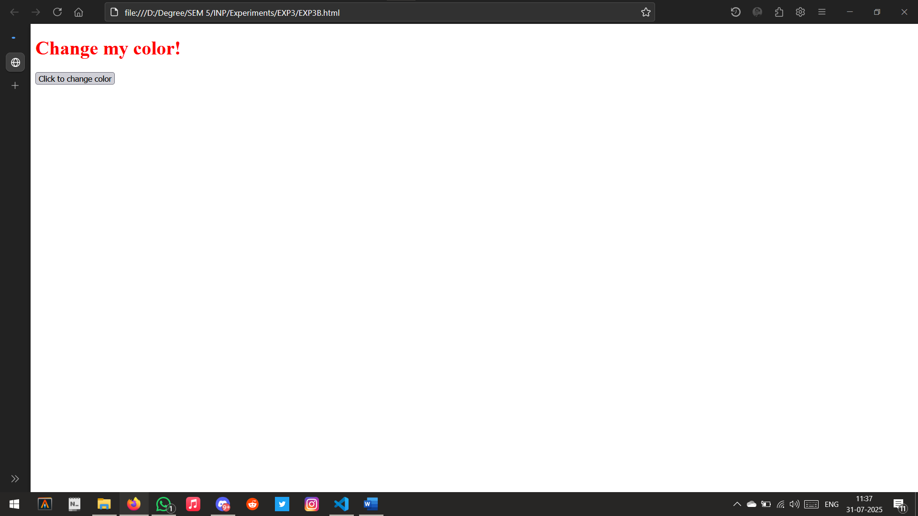

Q) Implement above using charge in different colors by clicking button using Java script

CODE:

<!DOCTYPE html>

<html>

    <head>

        <title>Color Changer</title>

    </head>

    <body>

        <h1 id="text">Click button to change color!</h1>

        <button onclick="changeColor()">Change Color</button>

        <script>

            const colors = ["red", "green", "blue", "orange", "purple"];

            let index = 0;

            function changeColor() {

                const text = document.getElementById("text");

                text.style.color = colors[index];

                index = (index + 1) % colors.length;

            }

        </script>

    </body>

</html>

OUTPUT:

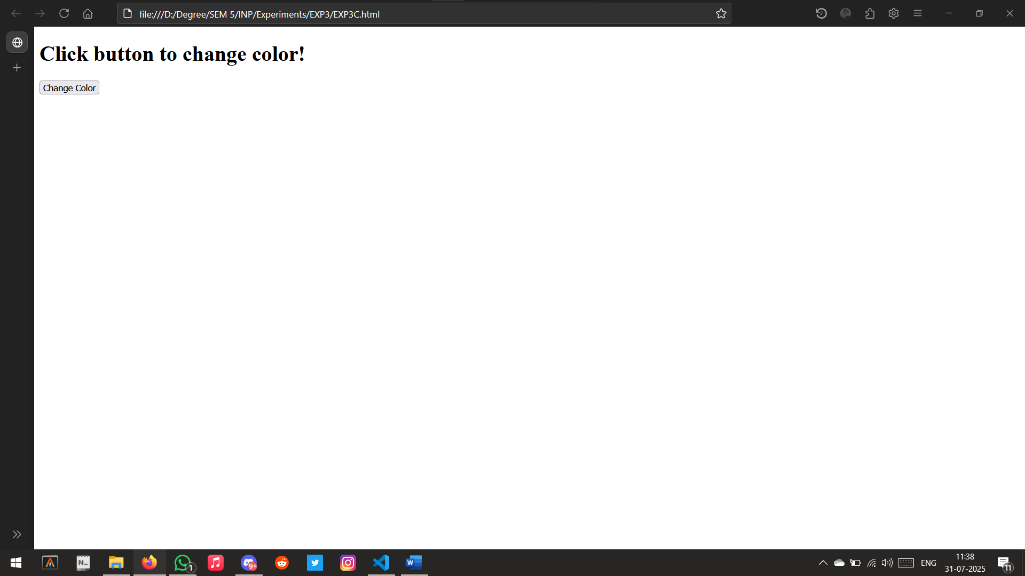

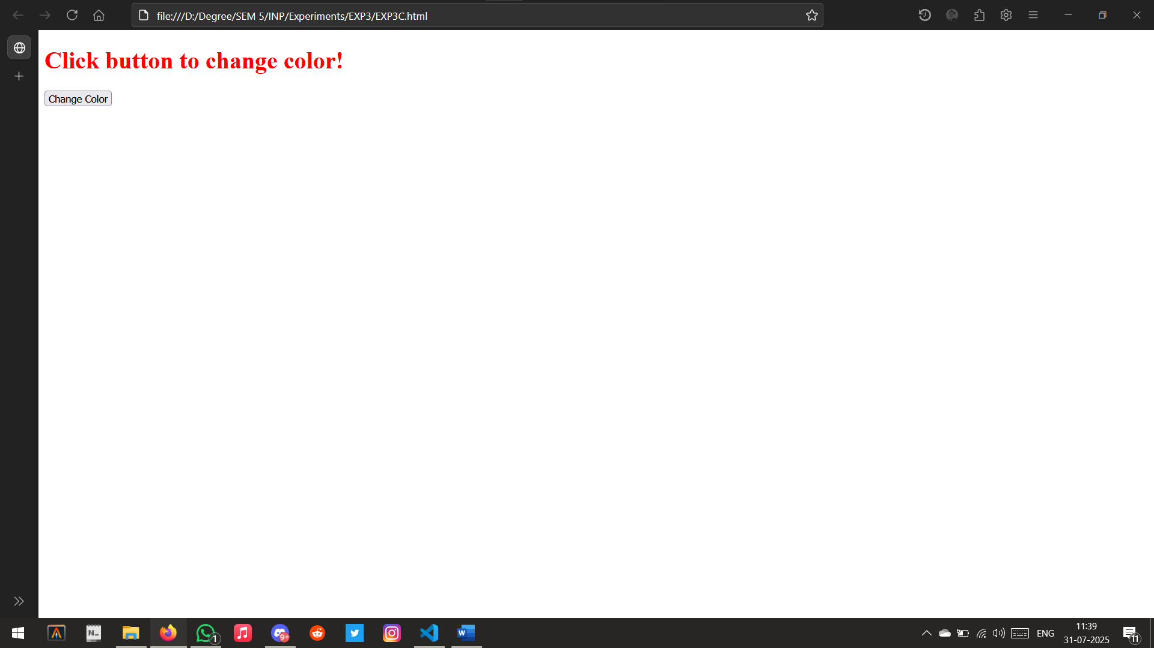

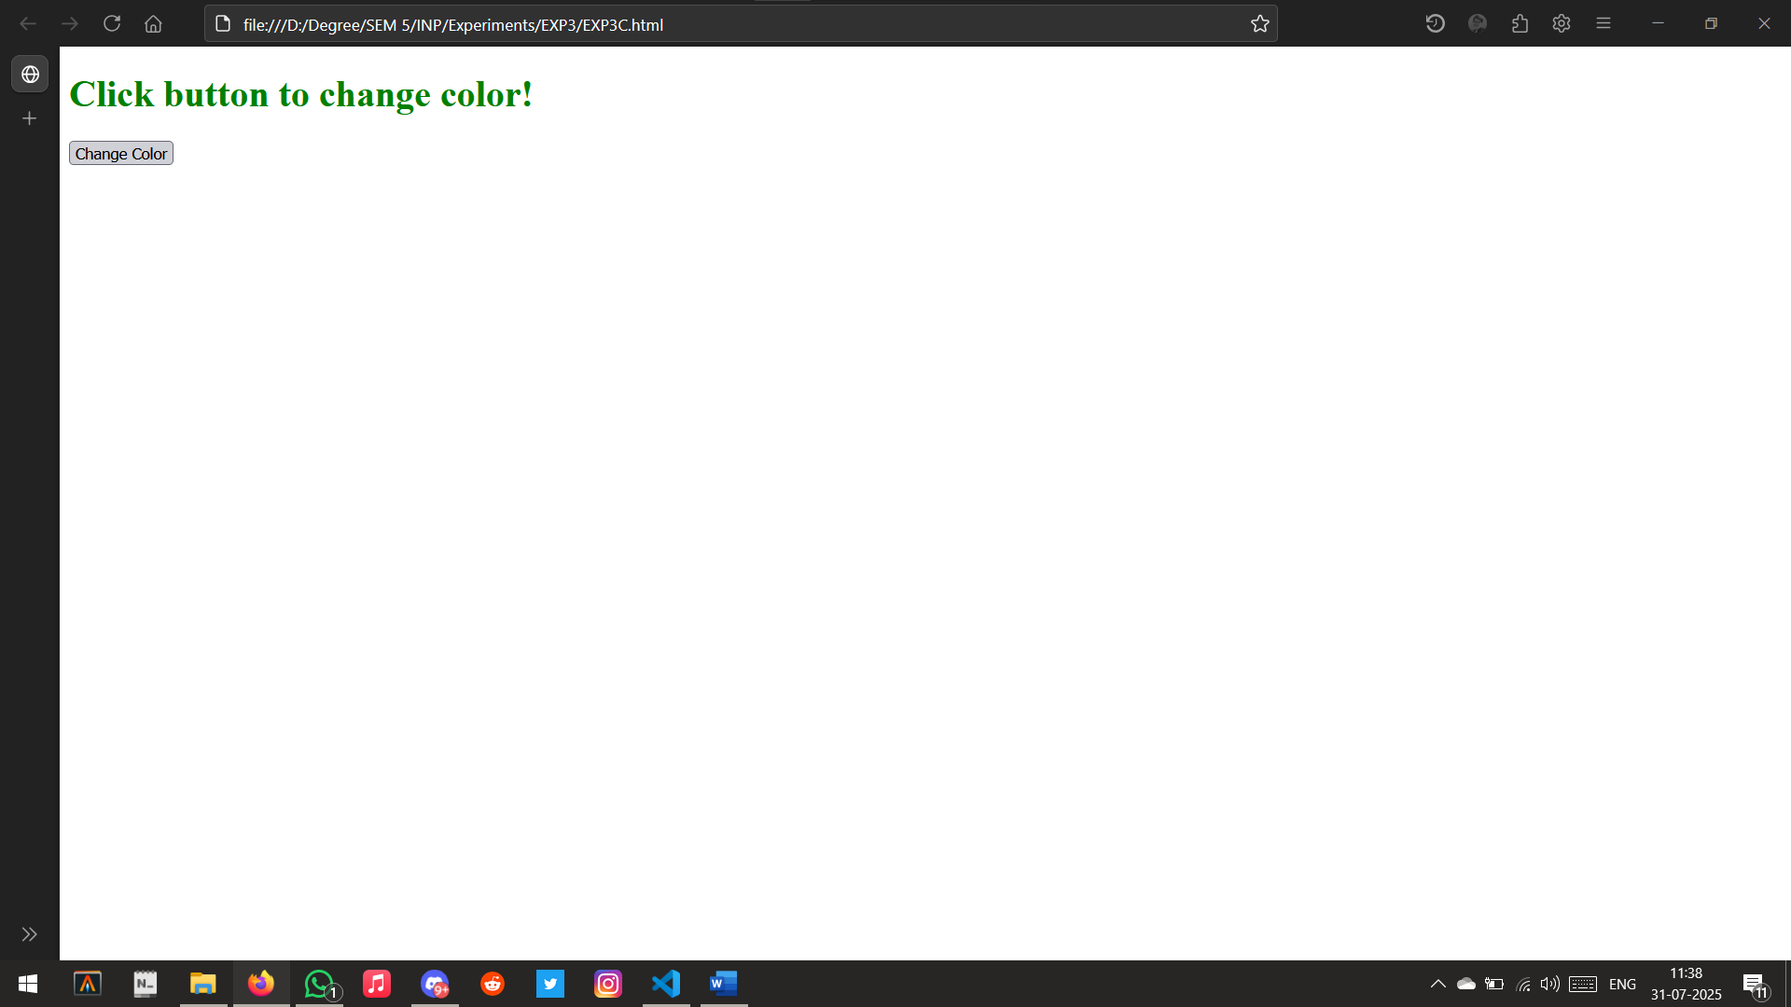 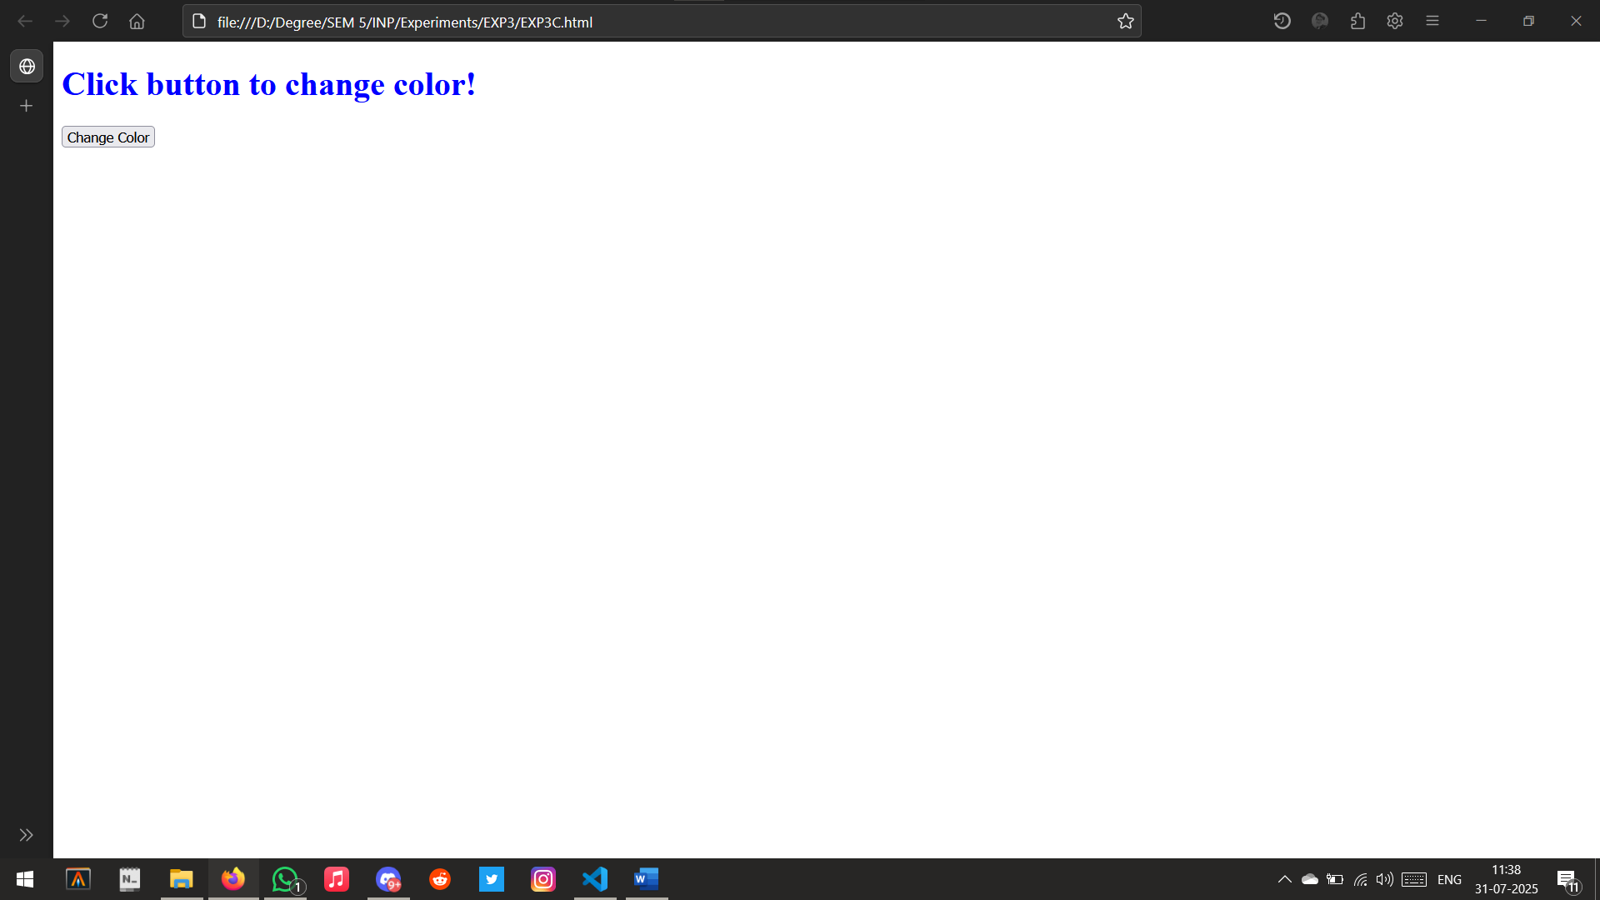

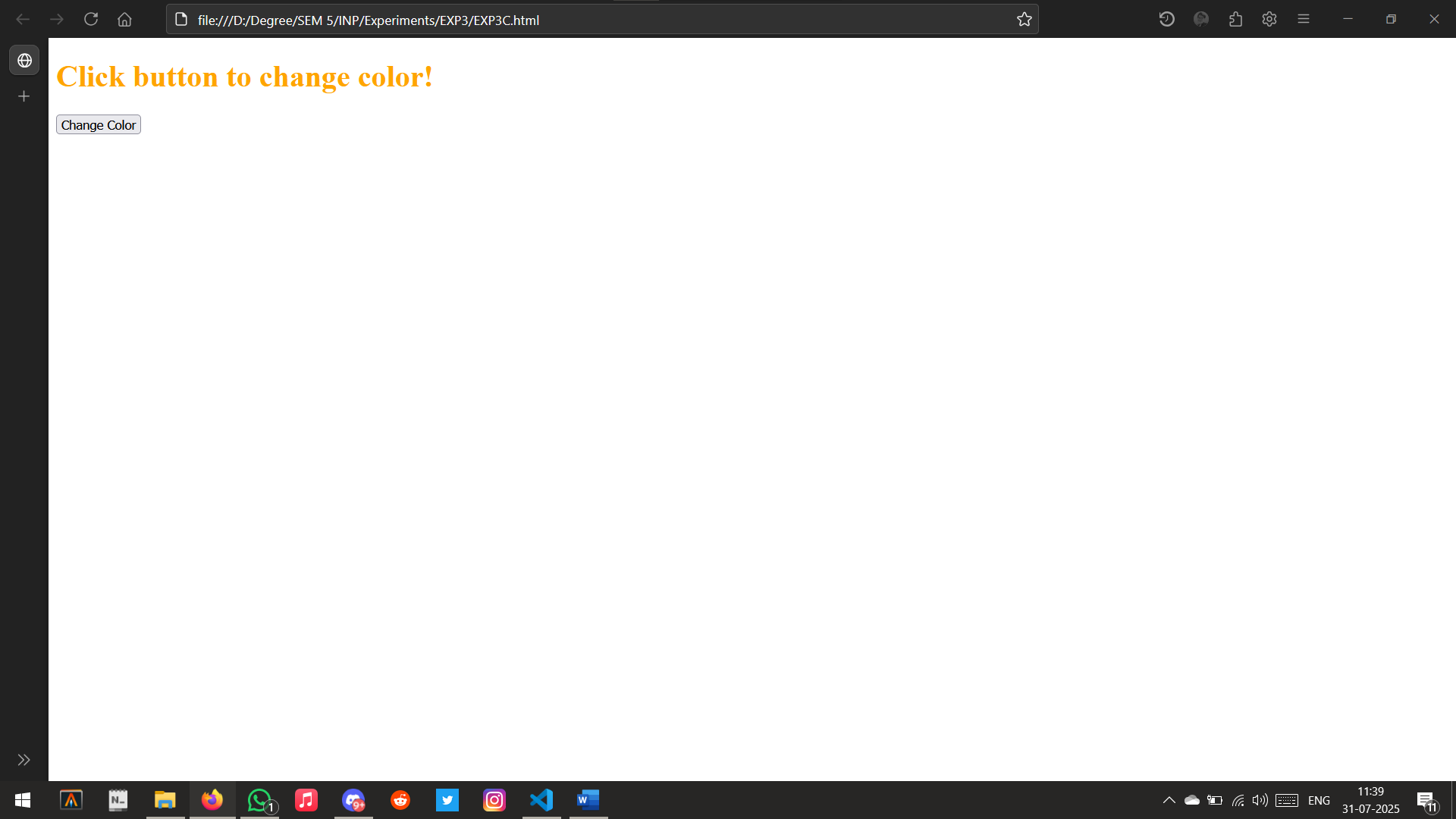

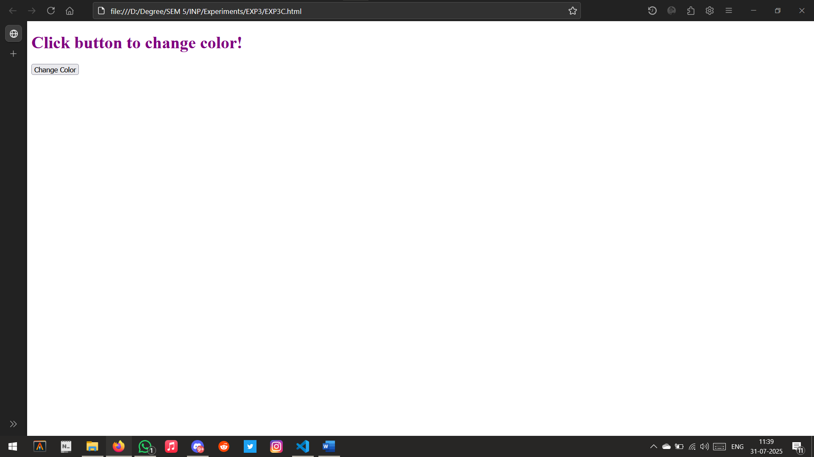

Q) Implement arithmetic operations using Java script both on browser and console

CODE (Browser):

<!DOCTYPE html>

<html>

    <head>

        <title>Arithmetic</title>

    </head>

    <body>

        <h2>Arithmetic Operations</h2>

        <input id="num1" type="number" placeholder="Enter number 1" />

        <input id="num2" type="number" placeholder="Enter number 2" />

        <button onclick="calculate()">Calculate</button>

        <p id="result"></p>

        <script>

            function calculate() {

                const n1 = parseFloat(document.getElementById("num1").value);

                const n2 = parseFloat(document.getElementById("num2").value);

                const result = `

        Sum: ${n1 + n2} <br>

        Difference: ${n1 - n2} <br>

        Product: ${n1 * n2} <br>

        Quotient: ${n1 / n2}

      `;

                document.getElementById("result").innerHTML = result;

            }

        </script>

    </body>

</html>

OUTPUT:

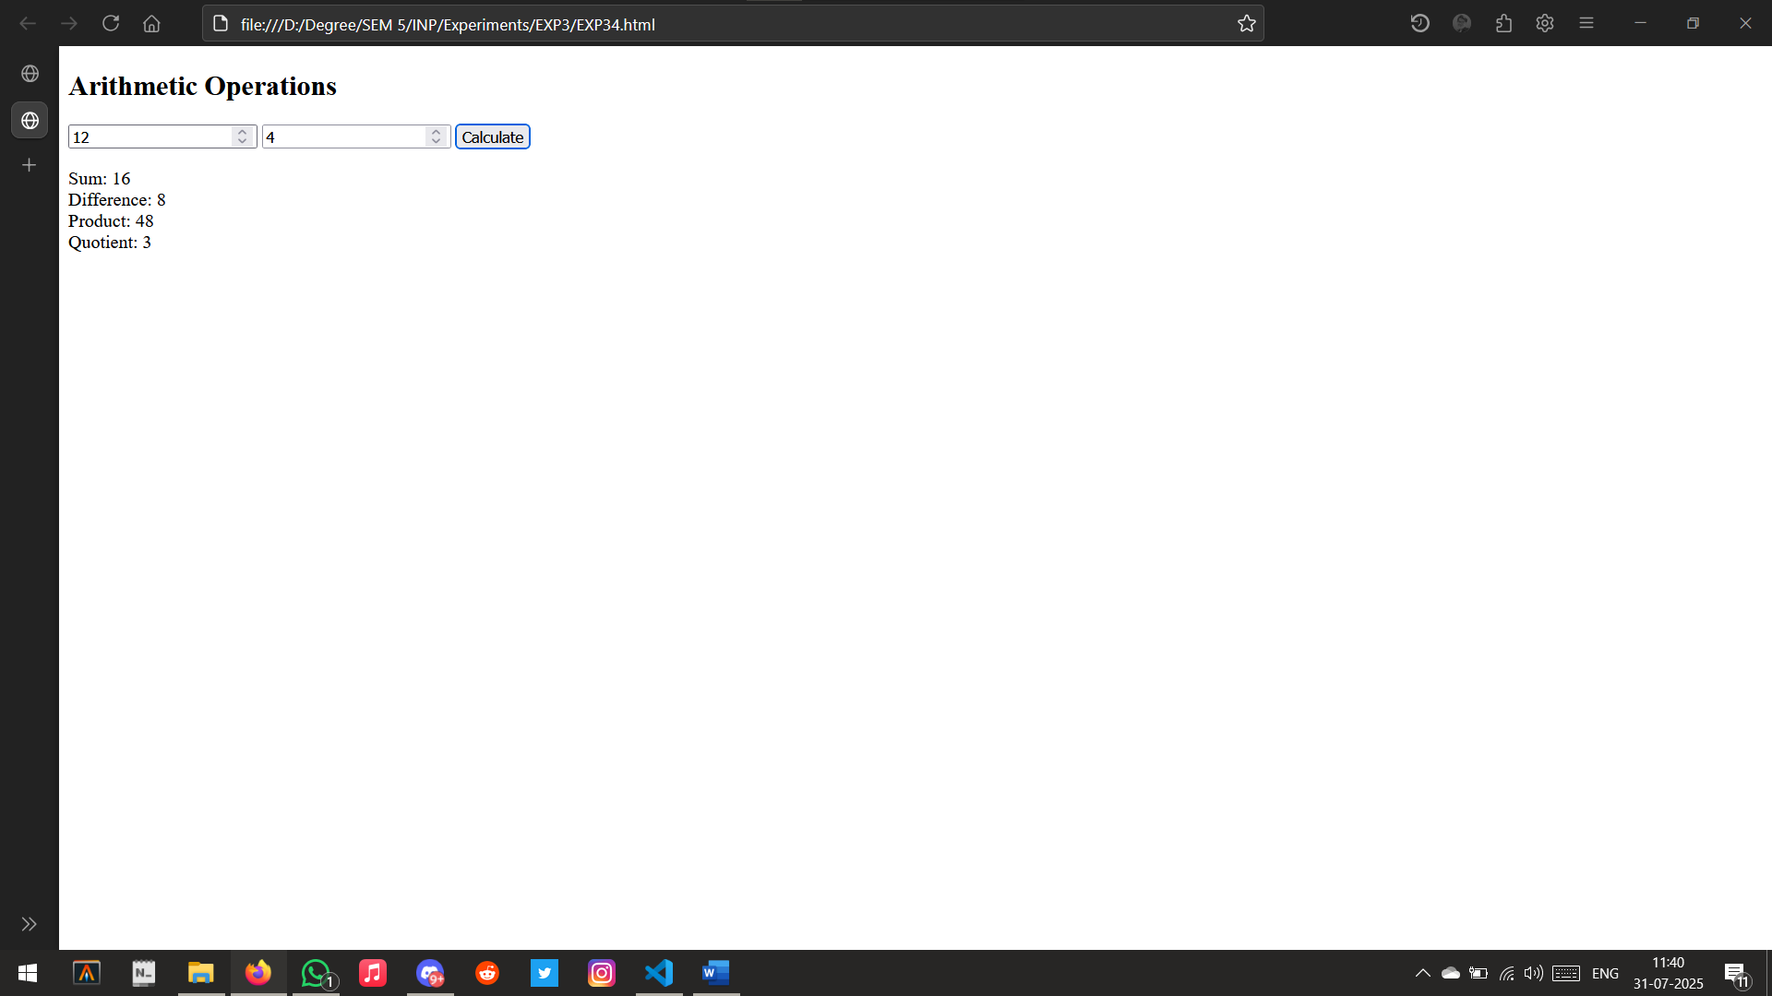

CODE (Console):

function calculate() {

    const n1 = 12;

    const n2 = 4;

    const result = `

        Sum: ${n1 + n2} <br>

        Difference: ${n1 - n2} <br>

        Product: ${n1 * n2} <br>

        Quotient: ${n1 / n2}

      `;

    console.log(result);

}

calculate();

OUTPUT:

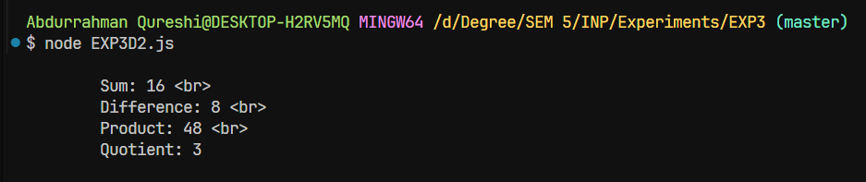

CONCLUSION: